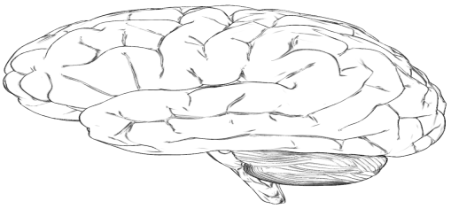
Cognitive Defusion

It could be said that language (including the thinking in our head) is one of our greatest blessings and biggest curses. It helps us travel to the moon (and someday the stars), and it also can cause some of our greatest suffering when we get stuck in thoughts of the past, pain of the present, or worries about the future.
With cognitive "defusion," we are
- Learning to notice thoughts rather than become caught up in (“attached” to) thoughts.
- Learning to put some distance between YOU and your thoughts and feelings.
- Learning to observe your thoughts and feelings as what they are: just thoughts and feelings.
  - This is NOT avoidance! You are not trying to avoid or distract from your thoughts/feelings; you are noticing them and looking at them in a different way.
  - For example: “What if I panic?” is just a thought. The feeling of anxiety is just a feeling.
  - You have thoughts, but you are not your thoughts. You are more than your thoughts.
  - You have feelings, but you are not your feelings. Your are more than your feelings.
  - You have memories, but you are not your memories. You are more than your memories.
    - Your thoughts, feelings and memories do not define you, nor do they have to rule your behavior.
    - They are no more powerful than you allow them to become.
    - You are BIGGER than your thoughts and feelings.

Adapted from Hayes, Steven C. (2005). Get out of your mind and into your life. Oakland, CA: New Harbinger Publications, Inc.
Techniques

The Mind | Treat “the mind” as an external object, almost as a separate person (e.g., “Well, there goes my mind thinking again” or “My mind is worrying again.”)
Just Noticing | Observe (notice) when you have a thought or feeling. For example, “So, I’m just noticing that I’m judging myself right now.”
Pop-Up Mind | Imagine that your negative thoughts are like Internet pop-up ads. Notice them and close them on out.
Monsters on the Bus | Treat scary thoughts and feelings as monsters on a bus you are driving. Just keep on driving in our chosen direction instead of doing what they say or trying to get them to leave!
Who is in Charge Here? | Treat thoughts as bullies: Whose life is this anyway? Your mind’s or yours?
Thoughts are Not Causes | If a thought is keeping you from doing something, ask yourself, “Is it possible to think that thought, as a thought, AND do x?” Try it out by purposefully thinking the thought while doing what it has been stopping.  Example: Think a thought such as “I can’t get out of bed” while getting out of bed. This shows you that you can do actions even when your mind tells you that you can’t.
Cell Phone (from he**) | Imagine that your negative chatter is like a cell phone that you cannot turn off and you always carry around. Let it ring as much as it likes. You don't need to answer or pay attention.
Repeating Words | Repeat a distressing word over and over again, until it loses its meaning: “Failure failure failure failure failure....”
And How Has that Worked for Me? | When you find yourself buying a thought (“I’m worthless”), back up for a moment and ask yourself, “How has that worked for me?” and if it hasn’t worked ask, “Which should I be guided by, my mind or my experience?”
Carry Cards | Write 3 difficult thoughts on a note card and carry them with you. This is a practice to remind you that you can carry your negative thoughts and your history and still be able to control your life.
Leaves on a Stream | Observe your thoughts and feelings as leaves floating down a stream.
Okay, You’re Right.  Now What? | If you are fighting to be right, assume that the President has decreed you are. Then ask yourself, “So what? What can I actually do to create a more valued life at this moment?”
Silly Voices | Say your thought out loud in a silly voice (i.e., Donald Duck).
Sing It Out | Sing your thoughts out loud.
Put it Out There | Write down negative thoughts you have about yourself on note cards. Tape them to your clothes and wear them around. Notice that you can still go about living your life even with carrying these thoughts around.
Carry Your Keys | Assign difficult thoughts and experiences to your keys. Then think the thought as a thought each time you handle your keys. Keep on carrying the keys and your thoughts (while also doing what matters)…
Take Your Mind for a Walk | Do you take your mind for a walk, or does your mind take you for a walk?
